Hate Speech and Toxic Comment Classification on Social Media
Abstract: The project may create an automated system to identify hate speech and toxic comments in social media based on a Bidirectional LSTM deep learning model. It cleans textual data, tokenizes it, and padding sequences with tokens, and then classifies it into six toxicity categories. The model enhances better efficiency in the moderation, lessening the negative interactions and promotes safer chatting processes online. Accuracy, Hamming loss, ROC-AUC, precision, recall and F1-score are used to assess performance. A Gradio web interface provides real-time toxicity prediction so that it can be used in practice and by the users.
Keywords: Hate Speech Detection, Toxic Comment Classification, Social Media Analysis, Bidirectional LSTM, Deep Learning, Natural Language Processing, Text Classification, Gradio Deployment, Multi-label Classification, Toxicity Prediction
Introduction
The project introduces a smart system that will detect hate speech and abusive remarks on social media. It applies deep learning to enhance safety on the internet, aid moderation, lessen abuse, and label harmful language precisely across numerous categories with labeled comments datasets nowadays work in practice on a community scale anywhere here continuously.
Technical Details
The program uses text cleaning, tokenization, padding, and vocabulary restriction and then trains a Bidirectional LSTM net [1]. Embedding layers are trained to learn patterns of semantic features, whereas dense layers are trained to predict six toxicity labels based on sigmoid output and binary crossentropy loss with Adam optimization and tracking of validation across different stages of the training process per epoch cycle with utmost care and deliberation.
Code Documentation
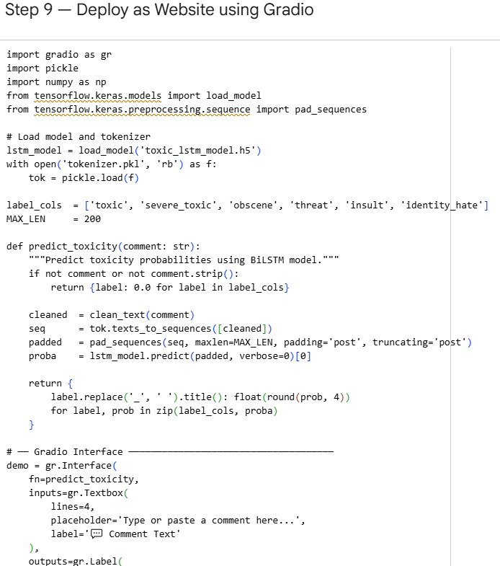
Fig 1: Gradio Web Interface Deployment Code
The notebook splits execution into a series of steps such as library setup, uploading datasets, exploration, preprocessing, modeling, evaluation, visualization, deployment and export. Functions refine comments, make predictions, store artifacts, and show metrics that maintainers can easily read when reviewing subsequent changes and debugging efficiently with well-read comments in all sections of the module at this stage.
Deployment Guide
The trained model is saved in H5 and tokenizer in vocabulary mappings. The system loads both files within Gradio, forms a textbox interface, provides the likelihood of toxicity, and opens a share link that lets users open in the browser to test instantly moderation through Gradio on any internet connection today and safely with ease across the globe.
Results and Analysis
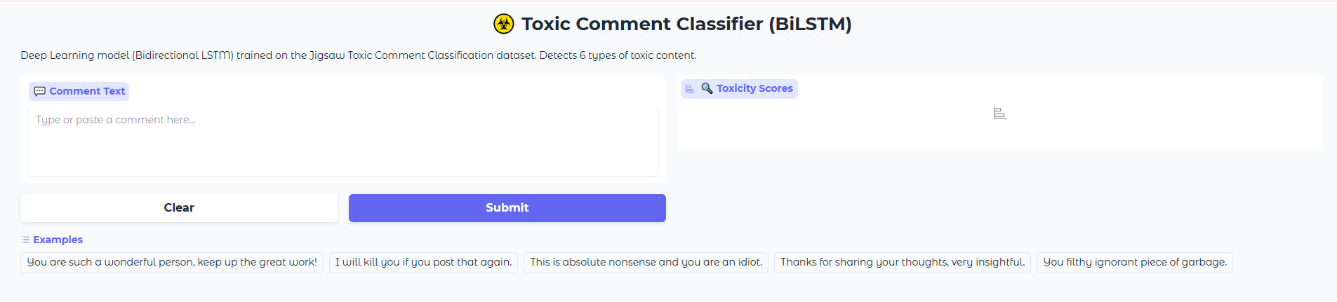
Fig 2: Toxic Comment Classifier Web Interface
The model evaluates filtered test comments through exact match accuracy, Hamming loss, ROC-AUC, precision, recall, and F1-score measures. The visualization techniques can be used to compare training and validation trends, identify patterns of confusion, and labelwise strengths and weaknesses to make additional tuning decisions once experiments have been successfully run with clear evidence displayed in a graphical format to those interested in the results today now.
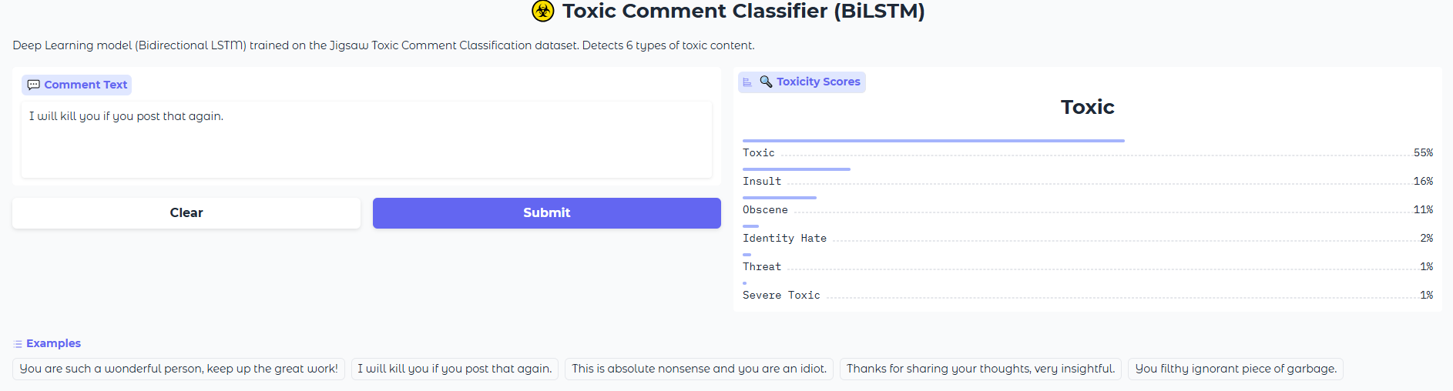
Fig 3:Toxic Comment Prediction Output
Conclusion
The project has shown that the Bidirectional LSTM classification is an effective tool in identifying hate speech and toxic comments in the text of social media. It facilitates scalable moderation, enhances community safety, and offers real time predictions using a basic web interface to institutions, platforms, educators, administrators, organizations all over the world on a daily basis efficiently and reliably, in practice today [2].
References
[1] Bonetti, A., Martínez-Sober, M., Torres, J.C., Vega, J.M., Pellerin, S. and Vila-Francés, J., 2023. Comparison between machine learning and deep learning approaches for the detection of toxic comments on social networks. Applied Sciences, 13(10), p.6038.
[2] Neog, M. and Baruah, N., 2024. A hybrid deep learning approach for Assamese toxic comment detection in social media. Procedia Computer Science, 235, pp.2297-2306.

